JAYPEE UNIVERSITY OF ENGINEERING & TECHNOLOGY, GUNA
DEPARMENT OF COMPUTER SCIENCE & ENGINEERING
Course: Computer Network Lab
Course Code: CS212

B. Tech. (CSE IV Sem.)

Experiment #4

Aim:Study of basic network command and Network configuration commands.

Apparatus (Software):Command Prompt and Packet Tracer.

Procedure: To do this experiment- follows these steps:

In this experiment- students have to understand basic networking commands e.g ping, tracert etc.
All commands related to Network configuration which includes how to switch to privilege mode and normal mode and how to configure router interface and how to save this configuration to flash memory or permanent memory.
This commands includes
- Configuring the Router commands
- General Commands to configure network
- Privileged Mode commands of a router
- Router Processes & Statistics
- IP Commands
- Other IP Commands e.g. show ip route etc.
ping:
ping(8) sends an ICMP ECHO_REQUEST packet to the specified host. If the host responds, you
get an ICMP packet back. Sound strange? Well, you can “ping” an IP address to see if a machine
is alive. If there is no response, you know something is wrong.
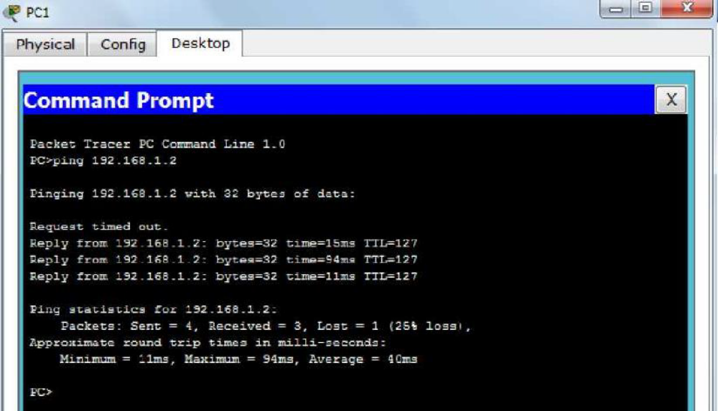

Traceroute:

Tracert is a command which can show you the path a packet of information takes from your computer to one you specify. It will list all the routers it passes through until it reaches its destination, or fails to and is discarded. In addition to this, it will tell you how long each 'hop' from router to router takes.

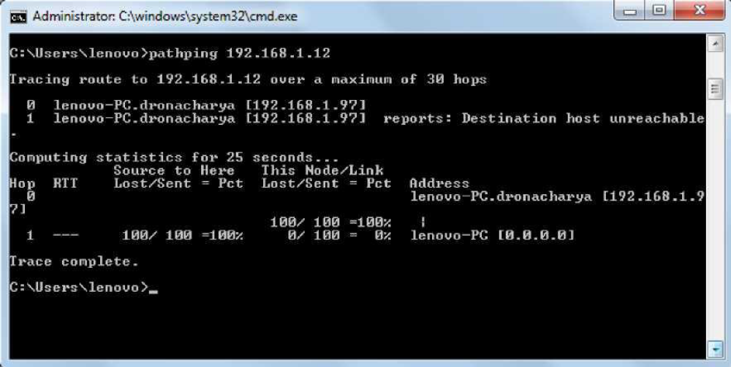

nslookup:

Displays information from Domain Name System (DNS) name servers.

NOTE :If you write the command as above it shows as default your pc's server name firstly

pathping:
A better version of tracert that gives you statics about packet lost and latency.

Getting Help
In any command mode, you can get a list of available commands by entering a question mark (?).
Router>?
To obtain a list of commands that begin with a particular character sequence, type in those
haracters followed immediately by the question mark (?).

Router#co?
configure connect copy
To list keywords or arguments, enter a question mark in place of a keyword or argument.Include a space before the question mark.

Router#configure ?
memory Configure from NV memory network Configure from a TFTP network host terminal
Configure from the terminal
You can also abbreviate commands and keywords by entering just enough characters to make the command unique from other commands. For example, you can abbreviate the show command to sh.

Configuration Files

Any time you make changes to the router configuration, you must save the changes to memory because if you do not they will be lost if there is a system reload or power outage. There are two types of configuration files: the running (current operating) configuration and the startup configuration.Use the following privileged mode commands to work with configuration files.

